Reconstruction DBQ Name: ________________________________________

North or South:
Who killed Reconstruction?

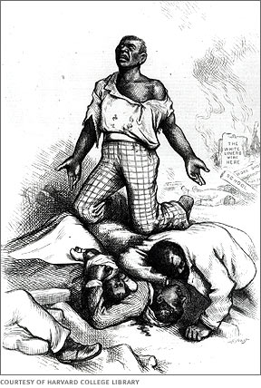
Overview: The twelve years after the Civil War proved to be a difficult time for America. Called Reconstruction by historians, this era saw an increase of freedom for former slaves. However, there was also great resistance to change. In 1877 attempts to reconstruct the South officially ended, leaving white-only governments in power. This Mini-Q asks you to decide who, North or South was most responsible for the end of Reconstruction.

Personal Writing Goals:

Hook Exercise: Reconstruction
Directions: Below are several groups that played a key role in the Reconstruction period. With a partner, read the descriptions of each group, and then read the headlines at the bottom of the page. Under each headline, draw an emoji symbol that expresses how each group would feel about the news. Be prepared to defend your answers.

Group: | Description:
Freedmen (F) | African Americans who were freed from slavery during and after the Civil War
Carpetbaggers (CB) | Northerners who went south after the Civil War to help Freedmen and Reconstruction
Scalawags (S) | Southern whites who supported Carpetbaggers and Freedmen
Radical Republicans (RR) | Northern Republican Congressmen who supported African-American citizenship and punishment for former Confederates
Ku Klux Klan (KKK): | A white supremacist group that opposed Reconstruction and rights for Freedmen

Headline A: “Congress Passes Enforcement Acts--Troops Sent South to Put Down the KKK” |  | Headline B: “Financial Panic of 1873 to Cause Severe Depression and Loss of 3 Million Jobs”
Group | Emoji | Group | Emoji
F: |  | F:
CB: |  | CB:
S: |  | S:
RR: |  | RR:
KKK: |  | KKK:

Headline C: “Hiram Revels Elected Senator From Mississippi in 1870--First Black Man to Enter Congress” |  | Headline D: “Rutherford B. Hayes Elected President in 1876---Agrees to Move Federal Soldiers out of Louisiana & South Carolina”
Group | Emoji | Group | Emoji
F: |  | F:
CB: |  | CB:
S: |  | S:
RR: |  | RR:
KKK: |  | KKK:

Clarifying the Question:

- Define the key terms of the question.
__________________________________________________________________________________________________

- What is the question asking you to do?
__________________________________________________________________________________________________

- Restate the question in your own words.
_________________________________________________________________________________________________

Bucketing: Place the letter of the document you will use for each reason in the corresponding bucket.

Reason #1:____________________ Reason #2: _____________________

Sourcing: Once you analyze the docs, fill in the blanks to summarize the source’s POV. This will help you include an evaluation of source in your final essay.

- Doc A: _____________________________________________________________________________________
- Doc B: _____________________________________________________________________________________
- Doc C: _____________________________________________________________________________________
- Doc D: _____________________________________________________________________________________

Thesis: Use the “chicken foot” to write your thesis after you’ve analyzed all the Docs.

Document A:
Source: Albion Tourgee, Letter on Ku Klux Klan Activities, New York Tribune, May 1870
Note: Tourgee was a white, Northern soldier who settled in North Carolina after the War. He served as a judge during Reconstruction and wrote this letter to the North Carolina Republican Senator, Joseph Carter Abbott.
It is my mournful duty to inform you that our friend John W. Stephens, State Senator from Caswell, is dead. He was foully murdered by the Ku-Klux in the Grand Jury room of the Court House on Saturday...He was stabbed five or six times, and then hanged on a hook in the Grand Jury room...Another brave, honest Republican citizen has met his fate at the hands of these fiends…  ...I have very little doubt that I shall be one of the next victims. My steps have been dogged for months, and only a good opportunity has been wanting to secure to me the fate which Stephens has just met...I say to you plainly that any member of Congress who, especially from the South, does not support, advocate, and urge immediate active and thorough measures to put an end to these outrages...is a coward, a traitor, or a fool. | 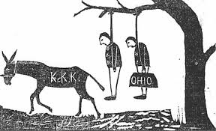  Image Source: Independent Monitor, Sept 1, 1868. Alabama Dept of Archives, Montgomery, Alabama

Document Title: |  | 1. Who wrote it?
2. What is the perspective of the source? |  | 3. Why was it written?
4. When was it written? |  | 5. Where was it written?
6. Is the source reliable? Why or why not?

Evidence: What important facts have you learned from this document?
Inference: How can you make sense of this fact? Interpret the fact.
Argument: How can you use this in your essay? Explain how the evidence proves who killed Reconstruction. .
Document B:
Source: Abram Colby, testimony to a joint House & Senate Committee in 1872
Note: Colby was a former slave who was elected to the Georgia State Legislature during Reconstruction.
Colby: On the 29th of October 1869, the Klansman broke my door open, took me out of bed, took me to the woods and whipped me three hours or more and left me for dead. They said to me, “Do you think you will ever voter another damned Radical ticket?” I said, “If there was an election tomorrow, I would vote the Radical ticket.” They set in and whipped me a thousand licks more, with sticks and straps that had buckles on the ends of them.  Question: What is the character of those men who were engaged in whipping you?  Colby: Some are first-class men in our town. One is a lawyer, one a doctor, and some are farmers...They said I had voted for Grant and had carried the Negroes against them. About two days before they whipped me they offered me $5,000 to go with them and said they would pay me $2,500 in cash if I would let another man go to the legislature in my place. I told them that I would not do it if they would give me all the country was worth...No man can make a free speech in my country. I do not believe it can be done anywhere in Georgia. | Image Source: Harper’s Weekly, Oct. 21, 1876  Caption: “Of course he wants to vote the Democratic ticket”  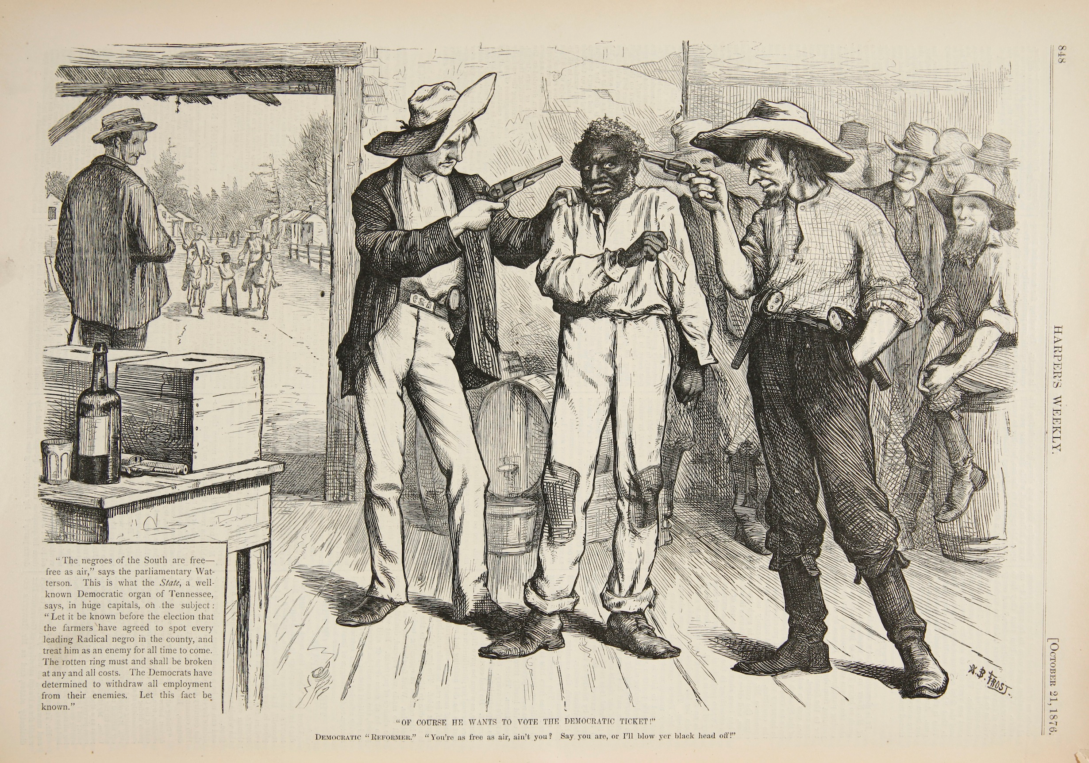

Document Title: |  | 1. Who wrote it?
2. What is the perspective of the source? |  | 3. Why was it written?
4. When was it written? |  | 5. Where was it written?
6. Is the source reliable? Why or why not?

Evidence: What important facts have you learned from this document?

Inference: How can you make sense of this fact? Interpret the fact.
Argument: How can you use this in your essay? Explain how the evidence helps you prove who killed Reconstruction.

Document C:
Source: Gerald Danzer, historian, The Americans, McDougal Littell (textbook publisher), 1998.
“in the 1870s, Northern voters grew indifferent to events in the South. Weary of the ‘Negro Question’ and ‘sick of carpet-bag’ government, many Northern voters shifted their attention to such national concerns as the Panic of 1873 and corruption in Grant’s administration...Although political violence continued in the South...the tide of public opinion in the North began to turn against Reconstruction policies.” | Image Source: Harper’s Weekly, 1876  Caption: “U.S. ‘In For It.’ I hope I shall get to the bottom soon.” *Note: U.S. are initials of President Ulysses S. Grant.  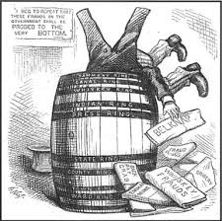

Document Title: |  | 1. Who wrote it?
2. What is the perspective of the source? |  | 3. Why was it written?
4. When was it written? |  | 5. Where was it written?
6. Is the source reliable? Why or why not?

Evidence: What important facts have you learned from this document?

Inference: How can you make sense of this fact? Interpret the fact.
Argument: How can you use this in your essay? Explain how the evidence helps you prove who killed Reconstruction.
Document D:
Source: Heather Richardson, The Death of Reconstruction: Race, Labor and Politics in the Post-Civil War North, 1865-1901. Harvard University Press, Cambridge, Massachusetts, 2001

In the fall of 1873, even the staunchly (firmly) pro-Grant and pro-freedman Boston Evening Transcript ran a letter...arguing that “the blacks, as a people, are unfit for political duty...The rising generation of blacks need a period of probation and instruction; a period long enough for the black to have forgotten something of his condition as a slave and learned much of the true method of taking care of himself and of performing the duties of any position to which he might dream of.  Image Source: The cover of Harper’s Weekly, March 14, 1874  Note: Northern artist’s portrayal of the South Carolina State Legislature during Reconstruction. | 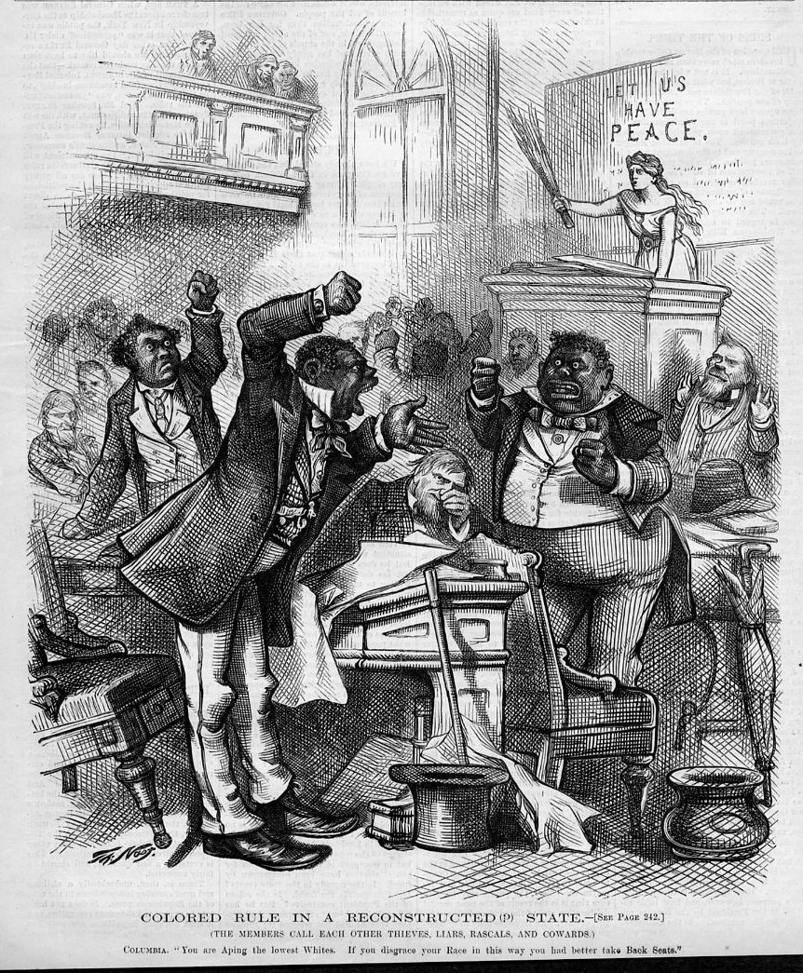

Document Title: |  | 1. Who wrote it?
2. What is the perspective of the source? |  | 3. Why was it written?
4. When was it written? |  | 5. Where was it written?
6. Is the source reliable? Why or why not?

Evidence: What important facts have you learned from this document?

Inference: How can you make sense of this fact? Interpret the fact.
Argument: How can you use this in your essay? Explain how the evidence helps you prove who killed Reconstruction.

Essay Outline:
Introductory Paragraph:
Hook (do last!): __________________________________________________________________________________________ ______________________________________________________________________________________________________
Historical Context:(from your Background Essay comic assignment) _________________________________________________ ______________________________________________________________________________________________________________________________________________________________________________________________________________________________________________________________________________________________________________________________________________________________________________________________________________________________________________________________________________________________________________________________
Thesis: ________________________________________________________________________________________________ ______________________________________________________________________________________________________

Body Paragraph 1:
Sub-claim: _____________________________________________________________________________________________ ______________________________________________________________________________________________________
Evidence/Argument: (At least 3 pieces of evidence and the argument that ties it back to the question)
______________________________________________________________________________________________________ ______________________________________________________________________________________________________
______________________________________________________________________________________________________
______________________________________________________________________________________________________
____________________________________________________________________________________________________________________________________________________________________________________________________________
____________________________________________________________________________________________________________________________________________________________________________________________________________
______________________________________________________________________________________________________
______________________________________________________________________________________________________
____________________________________________________________________________________________________________________________________________________________________________________________________________
____________________________________________________________________________________________________________________________________________________________________________________________________________
____________________________________________________________________________________________________________________________________________________________________________________________________________
____________________________________________________________________________________________________________________________________________________________________________________________________________
Body Paragraph 2: This should be the one you are arguing is more to blame.
Sub-claim: _____________________________________________________________________________________________ ______________________________________________________________________________________________________
Evidence/ Argument: (At least 3 pieces of evidence and the argument that ties it back to the question)
____________________________________________________________________________________________________________________________________________________________________________________________________________
______________________________________________________________________________________________________
______________________________________________________________________________________________________
____________________________________________________________________________________________________________________________________________________________________________________________________________
____________________________________________________________________________________________________________________________________________________________________________________________________________
______________________________________________________________________________________________________
______________________________________________________________________________________________________
____________________________________________________________________________________________________________________________________________________________________________________________________________
____________________________________________________________________________________________________________________________________________________________________________________________________________
____________________________________________________________________________________________________________________________________________________________________________________________________________
____________________________________________________________________________________________________________________________________________________________________________________________________________

Conclusion:
Although statement:(Tell why the North or South is more at fault than the other and why...,this is your counter-claim) _____________________________________________________________________________________________________ ______________________________________________________________________________________________________Conclusion statement: Restate your thesis
______________________________________________________________________________________________________ ______________________________________________________________________________________________________

